**Practical No: 3**

**Design using existing template.**

Step 1: Open Figma with login with your account.

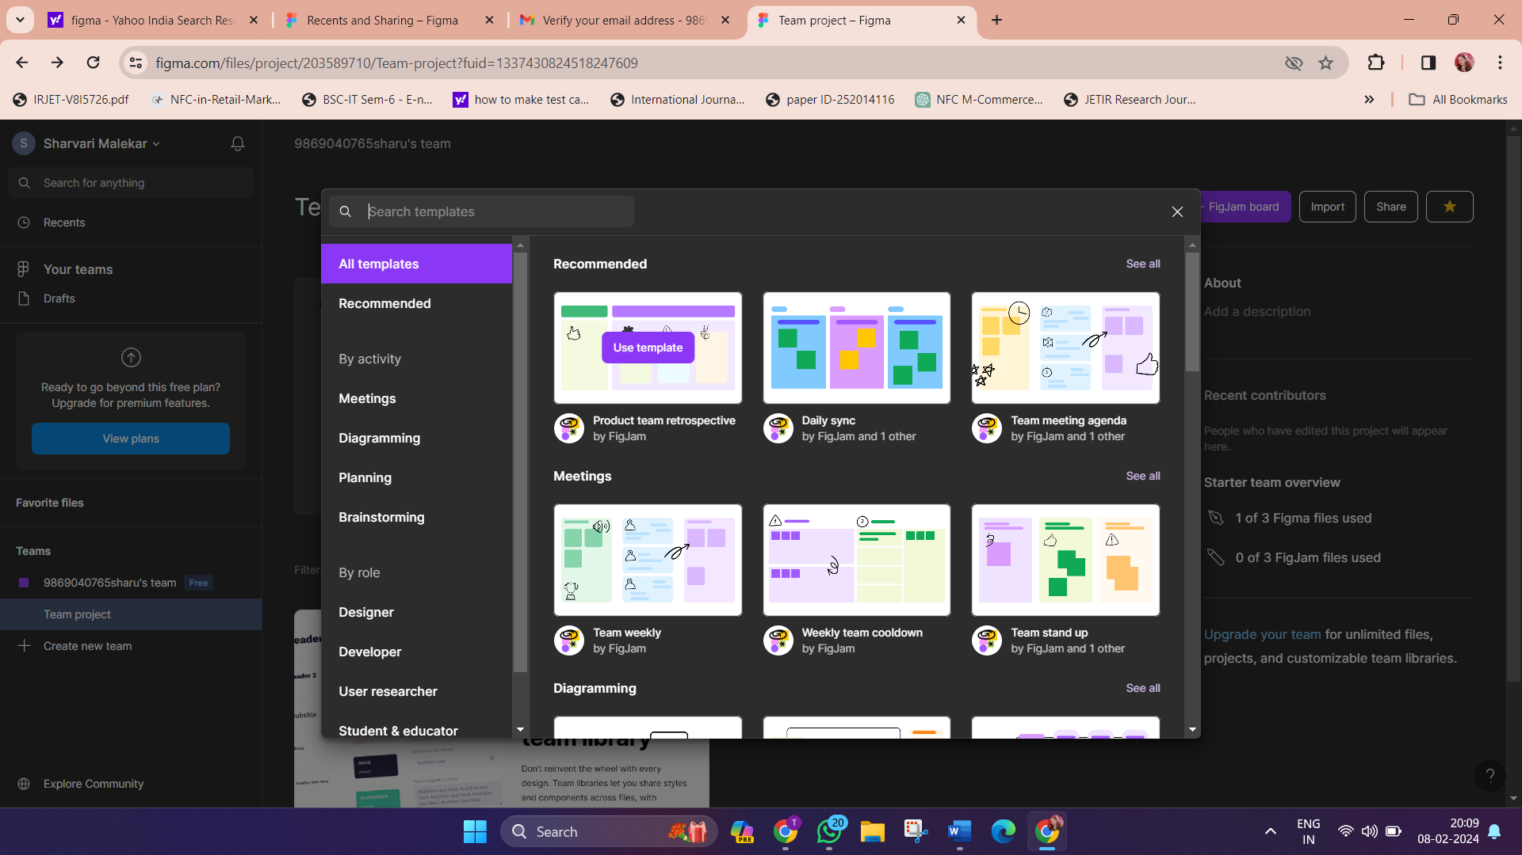

Step 2: Click on Team Project, go to Developer in that click on browse template.

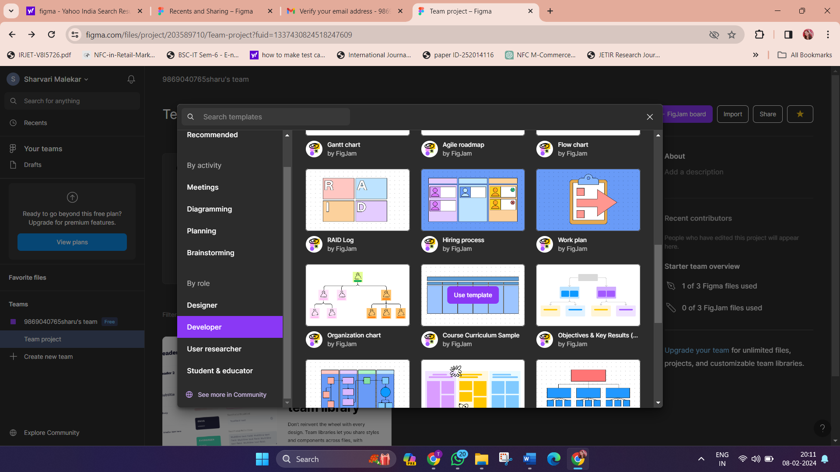

Step 3: Choose the template on particular topic and create a new user interface from existing template.

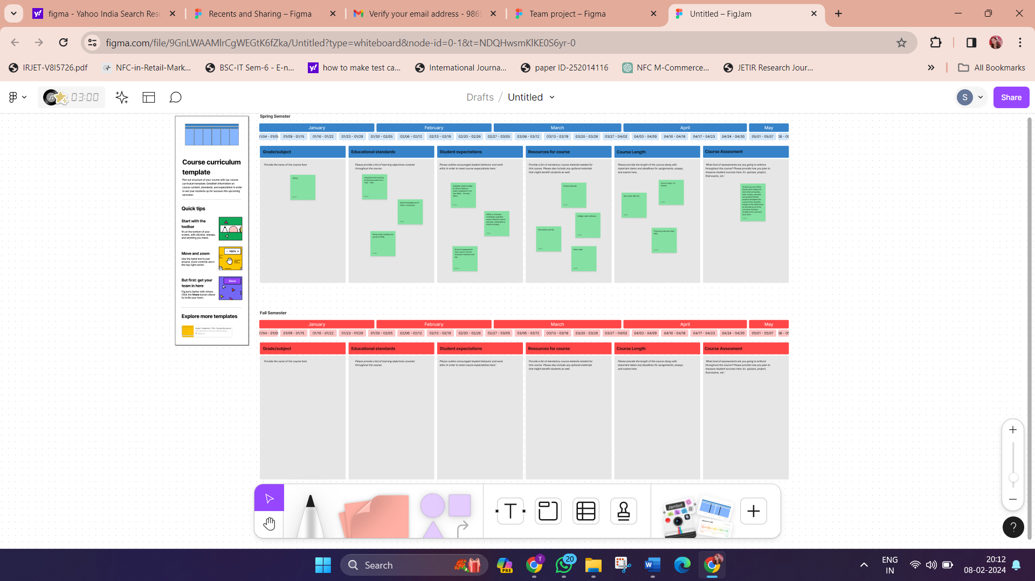

**Output:**

